5. Preventing Thread From Execution

The methods to prevent thread execution
- Yield()
- Join()
- Sleep()

- Yield:
- If a thread executes yield(), it causes to pause a current executing thread to give the chance for waiting threads of same priority.
- If there is no waiting thread or all waiting threads have low priority then same thread can continue its execution.
- If multiples threads are waiting in same priority, then which waiting thread will get the chance we cant expect and it depends on thread scheduler.
- The thread which is yielded (thread which calls the yield()), when it will get the chance once again? It depends on thread scheduler.
Note:
Consider t1, t2, t3 have same priority and t2 and t3 are in waiting state.
The thread t1 calls the yield() and it leaves the process state and goes to waiting state. After t1 yielded, it gives chance to t2 and t3 which have same priority. The Thread Scheduler (TS) can select any thread t2 or t3. Consider t2 is selected by TS. Now in waiting state, we have t3, and t1(yielded one). Now again once t2 is completed, the TS pick any thread in waiting state ( t3 or t1 )

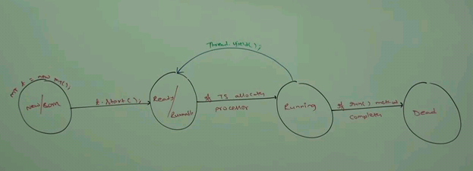

Its a native method which depends os level. Its not implemented in java but implemented underlying OS level.
Some platforms won’t provide proper support for yield().

Method:
public static void Thread.yield()

Example:
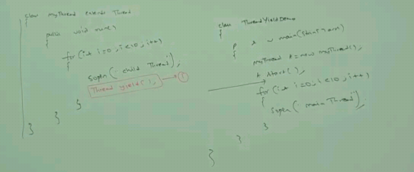

- Join
- If a thread wants to wait until completing some other thread, then we should go for join().
- If a thread t1 wants to wait until completing t2 because the output of t2 thread may be needed for the thread t1 and hence t1 has to call t2.join().
- If t1 executes t2.join, then t1 will be entered into waiting/blocked state until t2 completes.
- Once t2 completes, t1 entered into Ready/Runnable state. The Thread Scheduler will take care when it can continue based on scheduler algorithm.

Example – Marriage Card Distribution:
T1 (Venue Fix Activity) | T2 (Wedding Cards Printing) | T3 (Wedding cards distribution)
 | Before card printing, we need to fix venue first. So T2 has to wait until T1 Completing.  Hence T2 calls T1.join() | Before card distribution, card has to be printed. So T3 has to wait until T2 completes.  Hence T3 calls T2.join()

Chances of getting into Ready/Runnable state for t1.
1) After t2 completes
2) If waiting time expired - t2.join(long milli), t2.join(long mili,int nano)
3) If waiting thread got interrupted

Methods:
public void join(long milli) throws interrupted exception
public void join(long mili,int nano) throws interrupted exception
public void join() throws interrupted exception

- Always waiting thread should handle interrupted exception

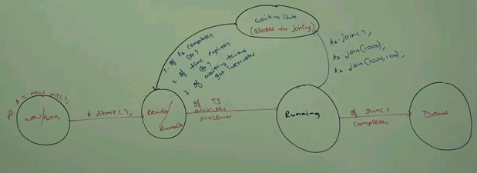

Case1:
Main thread waits until completing child thread.
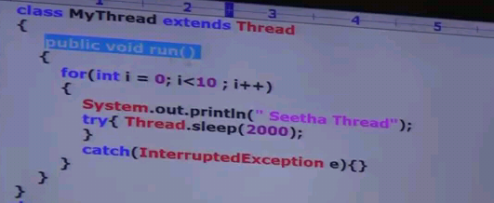
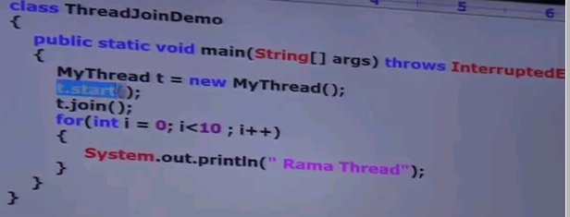

Case2:
Child thread waits until completing Main thread.
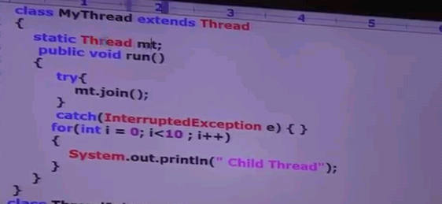

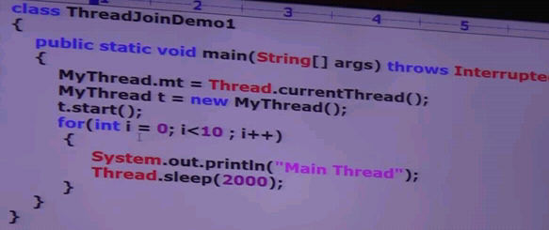

Note:
- if main thread calls join() on child thread, also child thread calls join() on main thread object, then both threads will be in waiting state forever and the program got stucked something like deadlock.
- If a thread calls join() on the same thread itself, then the program will be stucked (something like dead lock). In this case, thread has to wait infine amount of time.
Example for above Note case 2:
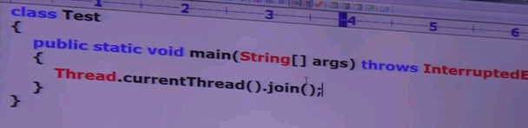

- Sleep

- If a thread don’t want to perform operation for a particular amount of time temporarily. It pauses the currently executing thread for a temporary period of time.

Methods:
public static void native Sleep(long milli) throws interrupted exception - native method
public static void Sleep(long milli, int nano) throws interrupted exception

- After calling sleep method, the currently executing thread entered into sleeping state for the specific amount of time.
- After the sleeping expires or if the sleeping thread got interrupted, the current thread entered into Ready/Runnable state. The Thread Scheduler will take care to allocate the processor based on scheduler algorithm.

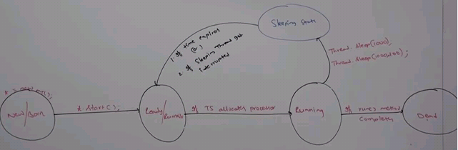

Example:
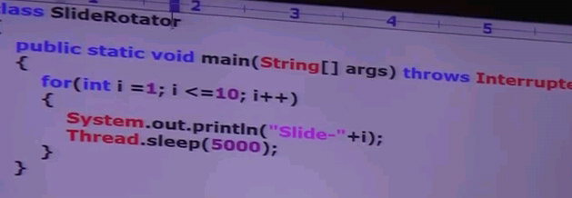

Thread Interruption:
- A thread can interrupt a sleeping thread (sleep()) or waiting thread (join()) by interrupt() of thread class.

Whenever we are calling interrupt(), if the target thread not in sleeping or waiting state, then there is no impact of interupt call immediately. Interrupted call will be waited, until targeted thread entered into sleeping or waiting state. If the target thread entered into sleeping or waiting state, then the interrupted call will interrupt the target thread.

If the target thread never entered into sleeping or waiting state in its life time, or the target thread died before calling interrupt, then there is no impact of interrupted call. This is the only case where interrupt call will be wasted.

Method:
public void interrupt()

Example:
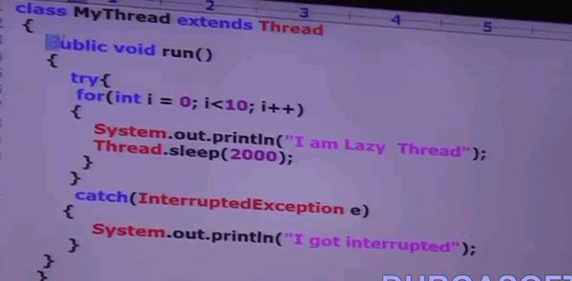

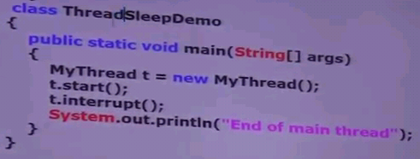

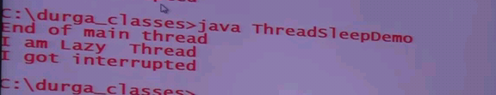

Example
